

language and literacy academy for learning

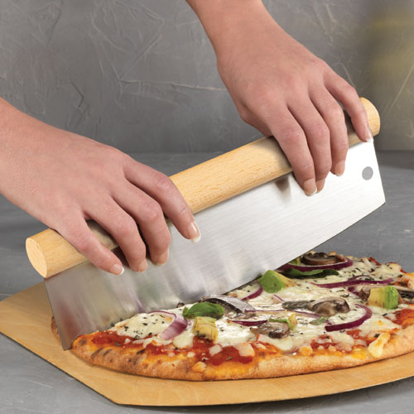

**WHAT & WHY**: Our school, now more than ever, needs your support and

every purchase makes a difference!

Shop for: gift wrap, kitchen, home items, candy & more.

**SCHOOL GOAL**: Profits from this fundraiser will go to benefit the students

**SALE END DATE**: 11/30/20

**CONTACT INFO**: Miyouri Bowman [llalpto2u@gmail.com](mailto:llalpto2u@gmail.com)



**Shop online and Share with Family and Friends:**

**Email, Text & Post to Social Media!**

**TO REGISTER**: 682903

**Visit:** SupportMySchool.org or

**Text:** “Register” to 636-202-1400

**School ID:** 682903

**Student ID:** Enter the last 7 digits of your phone number

(If you are registering more than one student, just change the last number of your phone number to create a second Student ID)



**Register above to be entered into a drawing**

**for a chance to win a Kindle Fire Tablet!**

**Share with Family, Friends & Co-Workers**